**Module 2: Practice Questions**

**Set 1:**

1. Create database “CustomerDatabase”. Query executions for the following questions should be made in CustomerDatabase
2. Create a table called “Customer”. See below meta data for table creation. Please note that “Id” is a primary key column.

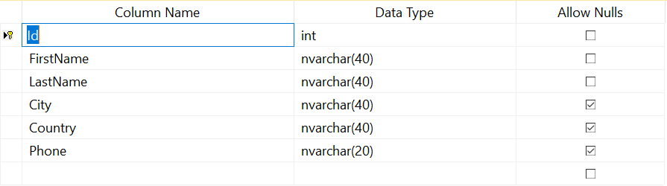

1. For the table created above, insert the following values:

(1,'Maria','Anders','Berlin','Germany','030-0074321'),

(2,'Ana','Trujillo','Mexico D.F.','Mexico','(5) 555-4729'),

(3,'Antonio','Moreno','Mexico D.F.','Mexico','(5) 555-3932'),

(4,'Thomas','Hardy','London','UK','(171) 555-7788'),

(5,'Christina','Berglund','Lulea','Sweden','0921-12 34 65'),

(6,'Hanna','Moos','Mannheim','Germany','0621-08460'),

(7,'Frederique','Citeaux','Strasbourg','France','88.60.15.31'),

(8,'Martín','Sommer','Madrid','Spain','(91) 555 22 82'),

(9,'Laurence','Lebihan','Marseille','France','91.24.45.40'),

(10,'Elizabeth','Lincoln','Tsawassen','Canada','(604) 555-4729')

1. Write a Query to Display the records in the customer table.
2. Thomas Hardy who resides in London, UK has now moved to Berlin, Germany. Update the city and Country of Thomas Hardy.
3. Now, Add a column Date_of_birth of type date.
4. Update the Date_of_birth column ‘1992-12-25’ for customers in Germany and ‘1992-10-20’ for customers in other countries. Note that you should write two update statements.
5. Create a new table “CustomerDB” with the same design as that of “Customer” table that you created above.
6. Now Insert the records from “Customer” table to “CustomerDB” table (Hint:Use Insert into…select * from)
7. Rename the ID column name to CustomerID in the “Customer” table.
8. Change the data type for FirstName and LastName field in “Customer” table from nvarchar(40) to nvarchar(50).

**Set 2:**

1. In our class lectures, we saw two tables of Products and their Categories (shown below) which explains the primary key and foreign key concepts. You are tasked to create the below tables along with the primary key and foreign key constraints. Also, when you create the tables, you will use your knowledge gained from the lectures to decide on the data type for each column.

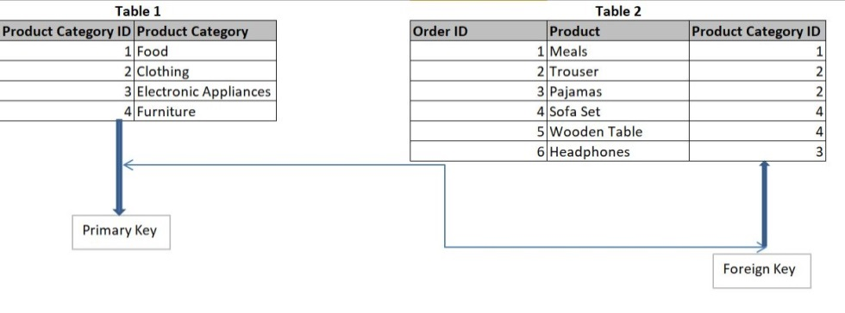

**Set 3 :**

1. Create database “TransactionData”.
2. Attached is an Excel File “Shipment_Data.xlsx”. You are asked to import this Excel file into MS SQL server (Please watch the recitation videos if you need to revise on how to import an excel file into MS SQL Server).
3. To the “Shipment_Data” table imported, add a column, total_ship_cost of data type “float”.
4. Update the total_ship_cost as Total_ship_cost = Linehaul_charge + Fuel_cost.
5. Export this new shipment_Data stats with total_ship_cost into an excel sheet (Please watch the recitation videos if you need to revise on how to export an excel file into MS SQL Server).

**Set 4:**

1. Use the database “TransactionData” that was created in Set 3. Create a table “Region”. It has following columns:

**Region_code** of type Int, primary key column

**RegionName** of type varchar(50)

1. Insert the following values into the region table:

|  |  |
| --- | --- |
| **Region_code** | **RegionName** |
| 1 | South |
| 2 | Central |
| 3 | North |

1. Use the database “TransactionData” that was created in Set 3. Create a table “Shipment_level_Stats”. It has the following columns:

**Shipment_ID** of type integer, autogenerated, Primary key column

**Shipment_Date** of type Date.

**Region_Code** of type Int, Foreign key column referencing Region_code column from “Region” table.

1. Enter 5 shipments to the above table starting from ‘2020-07-01’ to ‘2020-07-05’ (i.e, one shipment per day). Shipments shipped on first 2 days have region code as 1, 3rd day shipment with region code as 2 and last 2 day’s shipment with region code as 3.
2. You have now 2 new shipments shipped on ‘2020-07-06’ one each from West and East. Off late, your manager, Mahindra, had informed you that they will start receiving new shipments from East (Region code 4) and West (Region code 5) Regions as well. So your manager takes up the following step to make the changes:

**Step1**: Writes a query to Add the above two new shipments to the “Shipment_level_Stats” table.

Suddenly when he executes his query, He notices an error and seeks your help as he knows that you are taking SQL foundation course from Analytix Labs and he is very confident of your work. Please help your manager to resolve this issue with correct steps. Make sure referential integrity is still intact.